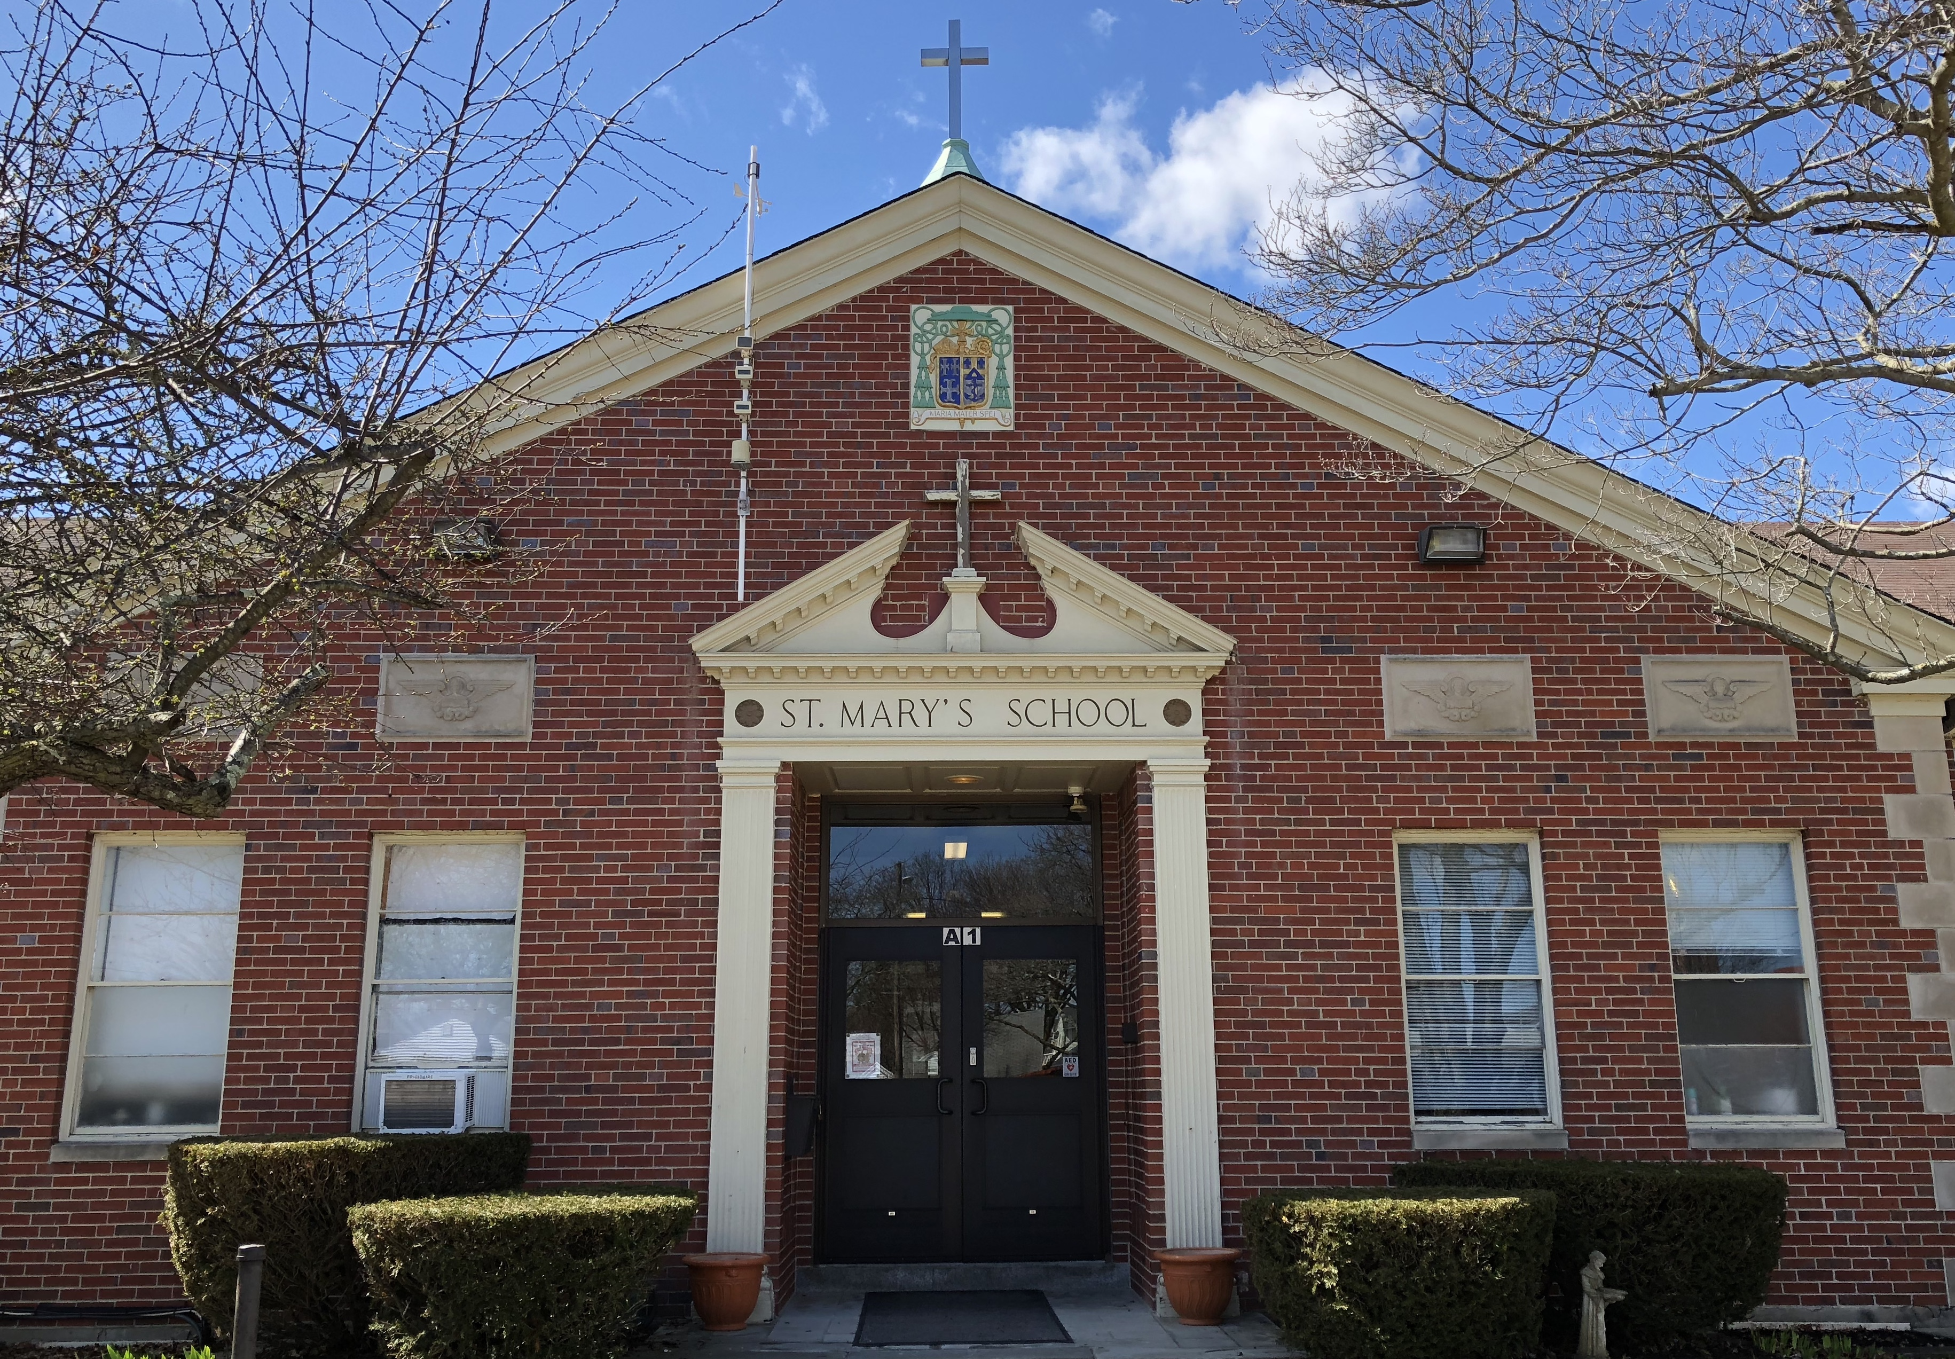
St. Mary’s School February 2024

Sun | Mon | Tue | Wed | Thu | Fri | Sat
 |  |  |  | 1 | 2 | 3
 |  |  |  |  | Happy Birthday, Violet H  Aliah V | Pasta Dinner
4 | 5 | 6 | 7 | 8 | 9 | 10
 | Happy Birthday,  Alexiana P |  | Happy Birthday,  Allyson K  Melina S  100th Day of School | Happy Birthday,  Ignacio S  Family Bingo  6:00-7:00 | Student Council Mtg
11 | 12 | 13 | 14 | 15 | 16 | 17
 | Happy Birthday,  Alicia G | Tiger Time  Faculty Meeting | Ash Wednesday Mass 9:30 |  | Happy Birthday,  Isaiah R | Happy Birthday,  Mateo H
18 | 19 | 20 | 21 | 22 | 23 | 24
School Vacation |  | Happy Birthday,  Juliana D |  | Happy Birthday,  Ms. Giampietro | Happy Birthday,  Nicholas M | Happy Birthday,  Estelle G
25 | 26 | 27 | 28 | 29
 | Happy Birthday,  Sophia P |  | Happy Birthday,  Julianna P  Nalania D  PTG Meeting

