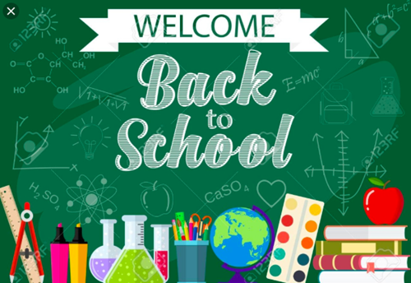
St Mary’s School
Middle School
2021-2022 Supply List

Religion Social Studies
1 Notebook & 1 Folder 1 Notebook & 1 Folder

Language Arts Math
1Composition Notebook &
1 Folder 1 Notebook
3-Ring Binder
1 Ruler
1 Inexpensive Calculator (Can be used for Science)

Science
1 Composition notebook and 1 1 inch binder with pockets
$25 Lab Fee (Students will be given a "science kit" at the beginning of the school year and will be theirs to keep after the school year, the beakers, eye droppers, etc. It can be their own kit for their entire middle school career.

Italian Art
1 Notebook & 1 Folder 1 Folder
3-Ring Binder 2 Large Glue Sticks
Pocket Dictionary for Italian Colored Pencils (can be used for Science) Crayons
Markers

Music PE/Health
1 Notebook & 1 Folder 2 Notebooks & 2 Folders

Renewable Supplies

Blue/Black/Red Pencils 12 # 2 Pencils
Erasers Highlighters (3 colors)
10 Large Glue Sticks Scissors
Markers Colored Pencils/Colored Pens
Pencil Case with Zipper Communication Folder
2 Flash Drives Index Cards & Small Storage Box
2 Boxes of Family Size Tissues 2 Large Rolls of Paper Towel
2 Containers Disinfecting Wipes 2 8 oz. Bottles of Hand Sanitizer
Headphones -students will need to bring in a pair of headphones from home
Google Chrome Carry Case
Backpack

Grade 8 students – 3 Mini Composition Books (3 ½ x 4 ½)

All School Supplies Should Be Brought to School on the 1st Day.

$5.00 for Student Planner
***$60.00 for Chrome Book Insurance will be due in January***

