St. Mary’s School
3rd Grade School Supply List
2021-2022

1 box - 24 count of Crayola Crayons or Twistables
1 box - 12 count Colored Pencils
1 package - #2 Pencils
1 pencil sharpener
1 - large pink eraser
1 - blunt tip scissors (5 inches)
4 - large glue sticks
1 - ruler with inches and centimeters
2 - red correcting pens
2 - blue or black pens
1 - yellow highlighter
1 - pencil pouch (lays flat and zippers)
1 - package of loose leaf notebook paper (wide ruled)
8 - composition notebooks (no spiral)
6 - Poly Twin Pocket Folders (red, blue, green, yellow, purple, and orange)
2 - containers of Lysol or Clorox Sanitizing Wipes
2 - 8oz bottles of hand sanitizer
2 - boxes of family size tissues
2 - rolls of paper towel
1 - lunchbox
1 - backpack - no wheels please

You may reuse anything you had left over from this school year, like pencil pouches, scissors, and rulers.

Please label all items with your child’s name in permanent marker.

Send all supplies in on the 1st day of school.

Thank you for your assistance and enjoy the summer!

~ Mrs. Ellis

***$5.00 to purchase Student Planner***

***$60.00 for Chrome Book insurance will be due in January***

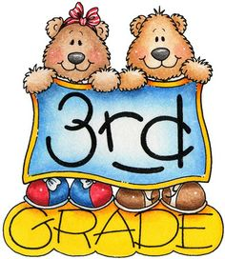
All students will need to bring in
headphones from home.

1 Shoe Box for all Art supplies

