St. Mary’s School
2nd Grade School Supply List
2021-2022

1 box - 24 count of Crayola Crayons or
1 Package of Twistables
1 box - 12 count Colored Pencils
2 packages - #2 Pencils
1 pencil sharpener
1 - large pink eraser
1 - blunt tip scissors (5 inches)
4 - large glue sticks
2 - Red/Black/Blue pens
1 - yellow highlighter
1 - pencil pouch (lays flat and zippers)
8 - composition notebooks
10 - Poly Twin Pocket Folders (red, blue, green, yellow, purple, and orange and additional colors)
2 - containers of Lysol or Clorox Sanitizing Wipes
2 - 8oz bottles of hand sanitizer
2 - boxes of family size tissues
2 - rolls of paper towel
1 - lunchbox
1 - backpack - no wheels please

Please label all items with your child’s name in permanent marker.

Chrome Book Case

Send all supplies in on the 1st day of school.

***$5.00 to purchase Student Planner***

***$60.00 for Chrome Book insurance will be due in January***

All students will need to bring in
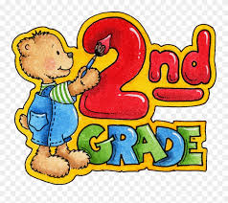
headphones from home.

