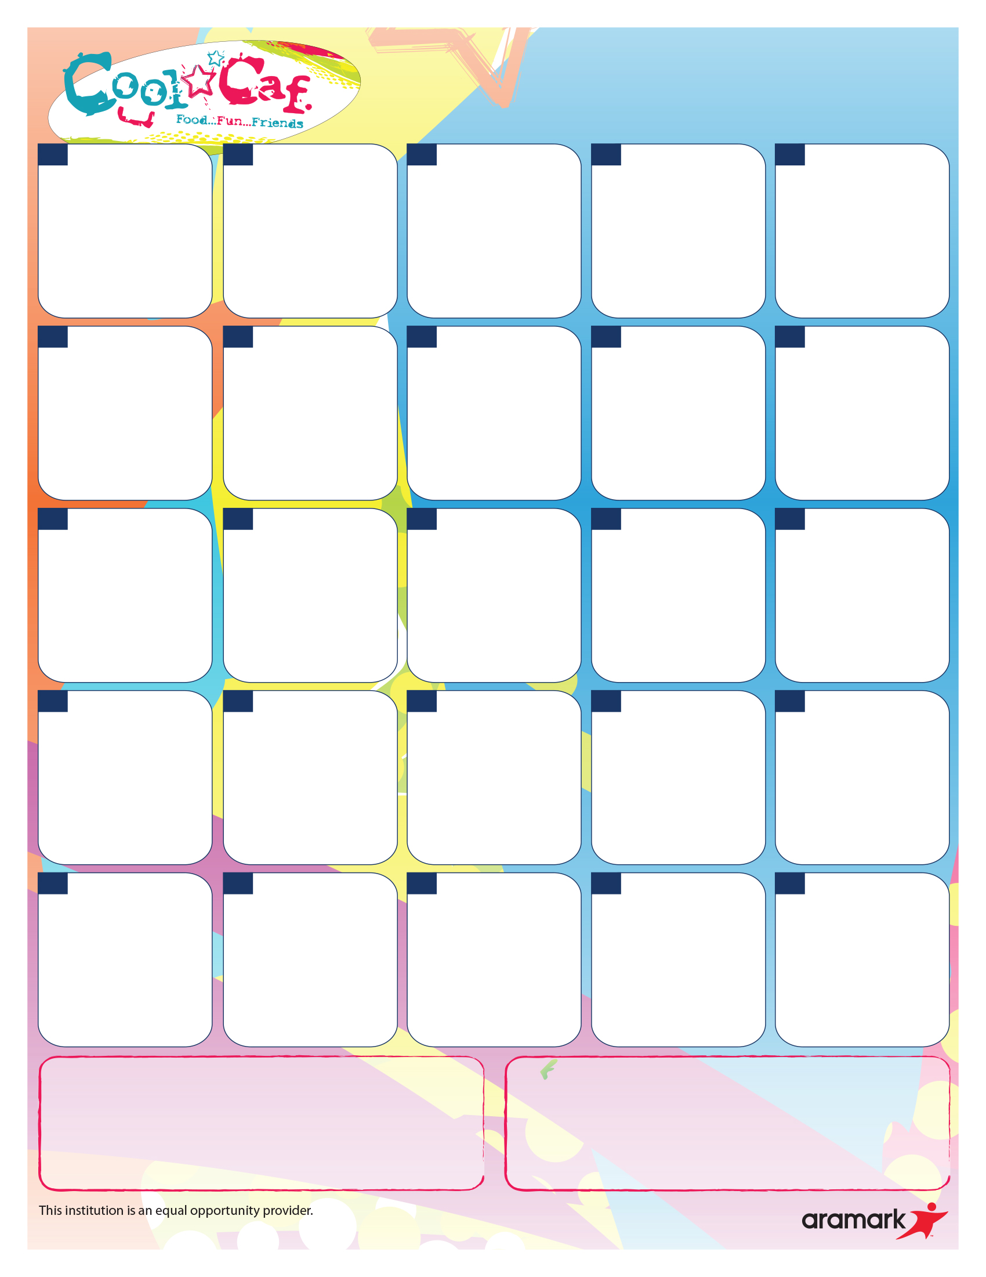

**1) Chicken & Cheese Burrito**

2) Personal Cheese Pizza

3) Chicken BLT Sub

4) Ham Pizza Salad w/ a roll

Fresh Fruit & Veg Bar

Celery Sticks

**1) Slow Roast Pulled Pork w/ Mac & Cheese**

2) Cheeseburger or Burger

3) Chicken BLT Sub

4) Ham Pizza Salad w/ a roll

Fresh Fruit & Veg Bar

BBQ Black Beans

**1) Popcorn Chicken Bowl w/ a breadstick**

2) Philly Steak & Cheese

3) Chicken BLT Sub

4) Ham Pizza Salad w/ a roll

Fresh Fruit & Veg Bar

Mashed Potatoes

**1) BBQ Chicken & Cheddar Flatbread**

2) Mini French Toast w/ an Omelet

3) Chicken BLT Sub

4) Ham Pizza Salad w/ a roll

Fresh Fruit & Veg Bar

Warm Cinn Apples

**1) Chicken Club Melt**

2) Personal Cheese Pizza

3) Ham & Cheese sub

4) Turkey & Cheese salad w/ a roll

Fresh Fruit & Veg Bar

Kale Caesar Salad

**27 Nat’l Chocolate Milk Day!**

**1) Soft Chicken/Cheese Tacos**

2) Roast Turkey & Gravy w/ a roll

3) Ham & Cheese sub

4) Turkey & Cheese salad w/ a roll

Fresh Fruit & Veg Bar

Roast Local Potatoes

**1) Oriental Popcorn Chicken over rice**

2) Mini Pancakes w/ sausage

3) Ham & Cheese sub

4) Turkey & Cheese salad w/ a roll

Fresh Fruit & Veg Bar

Chilled Edamame

**1) Poodle Noodles w/ a cheese stick**

2) Cheeseburger or Burger

3) Ham & Cheese sub

4) Turkey & Cheese salad w/ a roll

Fresh Fruit & Veg Bar

Local Grape Tomatoes

**1) Bacon/ Egg & cheese Bagel**

2) Chicken Patty Sandwich

3) Ham & Cheese sub

4) Turkey & Cheese salad

w/ a roll

Fresh Fruit & Veg Bar

Seasoned Corn

**18 Fuel**

**20 Ace’s Birthday Bash!**

**1) Pizza Grilled Cheese**

2) Personal Cheese Pizza

3) Sunny butter & jelly sandwich

4) Fruit, cheese & yogurt w/ a pretzel

Fresh Fruit & Veg Bar

Broccoli Trees

**1) Tater Bite Chicken Nachos w/ tortillas**

2) Corn Dog

3) Sunny butter & jelly sandwich

4) Fruit, cheese & yogurt w/ a pretzel

Fresh Fruit & Veg Bar

Kickin’ Pinto beans

**1) Bruschetta Flatbread**

2) Mini Waffle w/ an omelet

3) Sunny butter & jelly

sandwich

4) Fruit, cheese & yogurt w/ a pretzel

Fresh Fruit & Veg Bar

Roast Sweet Potatoes

**1) Cheese Ravioli w/ Marinara**

2) Cheeseburger or Burger

3) Sunny butter & jelly sandwich

4) Fruit, cheese & yogurt w/ a pretzel

Fresh Fruit & Veg Bar

Cucumber coins

**1) Taco bites w/ Salsa**

2) Chicken Patty Sandwich

3) Sunny butter & jelly sandwich

4) Fruit, cheese & yogurt w/ a pretzel

Fresh Fruit & Vegetable Bar

Potato Wedges

**1) Mozzarella melt w/ Dunkin’ Sauce**

2) Pepperoni Pizza

3) Chicken Caesar Wrap

4) Buffalo Chicken Salad w/ a breadstick

Fresh Fruit & Vegetable Bar

Garden Salad

**1) Grilled Cheese & Bacon**

2) Chicken Patty Sandwich

3) Chicken Caesar Wrap

4) Buffalo Chicken Salad w/ a breadstick

Fresh Fruit & Vegetable Bar

Mashed Potatoes

**1) Loaded Baked Potato w/ a breadstick**

2) Mini Pancakes w/sausage

3) Chicken Caesar Wrap

4) Buffalo Chicken Salad w/ a breadstick

Fresh Fruit & Vegetable Bar

Seasoned corn

**1) Soft Beef & Cheese Taco**

2) Chicken Nugget w/ a

breadstick

3) Chicken Caesar Wrap

4) Buffalo Chicken Salad w/ a breadstick

Fresh Fruit & Vegetable Bar

Chilled Garbanzo beans

**10 Lucky Tray Day!**

**1) Pasta & Meat sauce w/a breadstick**

2) Cheeseburger or Burger

3) Chicken Caesar Wrap

4) Buffalo Chicken Salad w/ a breadstick

Fresh Fruit & Vegetable Bar

Green Beans

**1) Hot Dog**

2) Personal Cheese Pizza

3) Tuna Sub

4) Chicken Caesar Salad w/ goldfish crackers

Fresh Fruit & Vegetable Bar

Fresh Local Zucchini

**1)** **Beef & Cheese Nachos**

2) Chicken Tenders w/ a breadstick

3) Tuna Sub

4) Chicken Caesar Salad w/ goldfish crackers

Fresh Fruit & Vegetable Bar

Baked beans

**1) Meatball Pizza Sub**

2) Cheeseburger or Burger

3) Tuna Sub

4) Chicken Caesar Salad w/

goldfish crackers

Fresh Fruit & Vegetable Bar

Spinach Salad

**1) Deluxe Chicken Parmesan Sandwich**

2) Mini FT w/ an omelet

3) Tuna Sub

4) Chicken Caesar Salad w/ goldfish crackers

Fresh Fruit & Vegetable Bar

Seasoned Carrots

**Did you know?**

**A new free and reduced application each year.**

**Free/Reduced applications:** [www.myschoolapps.com](http://www.myschoolapps.com)

**All grains served are whole grain rich!**

***Make your server aware of any food allergies***

**Bagel fun lunch is still available daily as Choice 5!**

Whole grain bagel, Lowfat Trix yogurt, Lowfat cream cheese

and a string cheese stick.

Lunch Prices: Paid $2.50 Reduced $.40 Milk Only $.50

Contact Us: Tricia Wright, General Manager [aramark@cpsed.net](mailto:aramark@cpsed.net) 270-8069

**St Marys School Lunch**

**September 2019**

**25**

**19**

**30**

Labor Day

See you tomorrow!

**1) Breakfast for Lunch Pancakes w/ Yogurt**

2) Pizza Munchable

Fresh Fruit & Veg Bar

Garden Salad

**1**

**2**

**3**

**4**

**23**

**24**

**26**

**16**

**17**

**13**

**12**

**11**

**9**

**6**

**5**

**4**

**3**

**2**