Out of Uniform

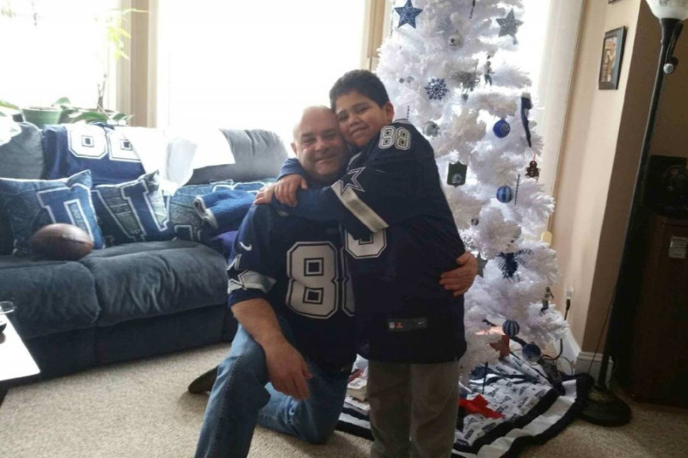
We would like to reach out to the St. Mary’s community in helping us support a former student,
Domenic Balassone, age 10.
Domenic sadly lost his father, Henry Balassone, age 51 last Tuesday, September 19th. Henry was unexpectedly diagnosed with Pancreatic cancer only weeks ago and passed suddenly.

St. Mary’s will be hosting a “Sports Theme”
Out of Uniform Day in Henry’s honor on
Wednesday October 4th,
St. Mary’s will send your donations to:
www.gofundme/Henry.Balassone.com
All proceeds will be entrusted to Domenic’s College Fund.
Thank you for your support in advance

